# Troubleshooting Common Pitfalls in the Intro Lab

## Intro Lab: not having a GitHub Account

Suggesting to all participants that they get a GitHub account at the beginning helped

## Intro Lab: forget the password while creating the cluster / MongoDB instance

Remind them to use something simple like admin/password, or to take note of the password. Also, tell them **not to use special characters**. If they use an @ symbol, it messes up the connection string.

## Intro Lab: not giving network access to 0.0.0.0/0

If this is the case the import tool will fail and remind us about that

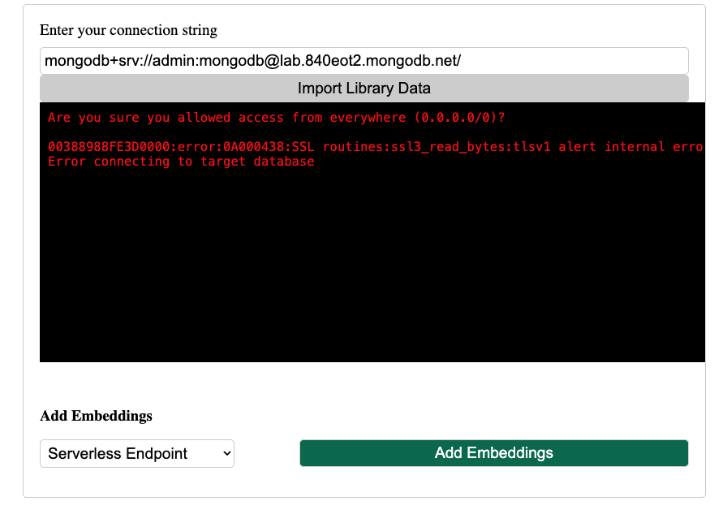

# 

## Intro Lab: reloading the import tool and losing the connection string

Remind them that if the import tool fails they need to reload the page, and the URL will be lost.

## Intro Lab: import tool doesn't work in Firefox

Need to confirm and fix this, but faced this issue

## Intro Lab: closing the library app's Simple browser

If you close the Simple browser tab, you can open it again by going to Ports > Client, hover "Forwarded Address", click on the World icon.

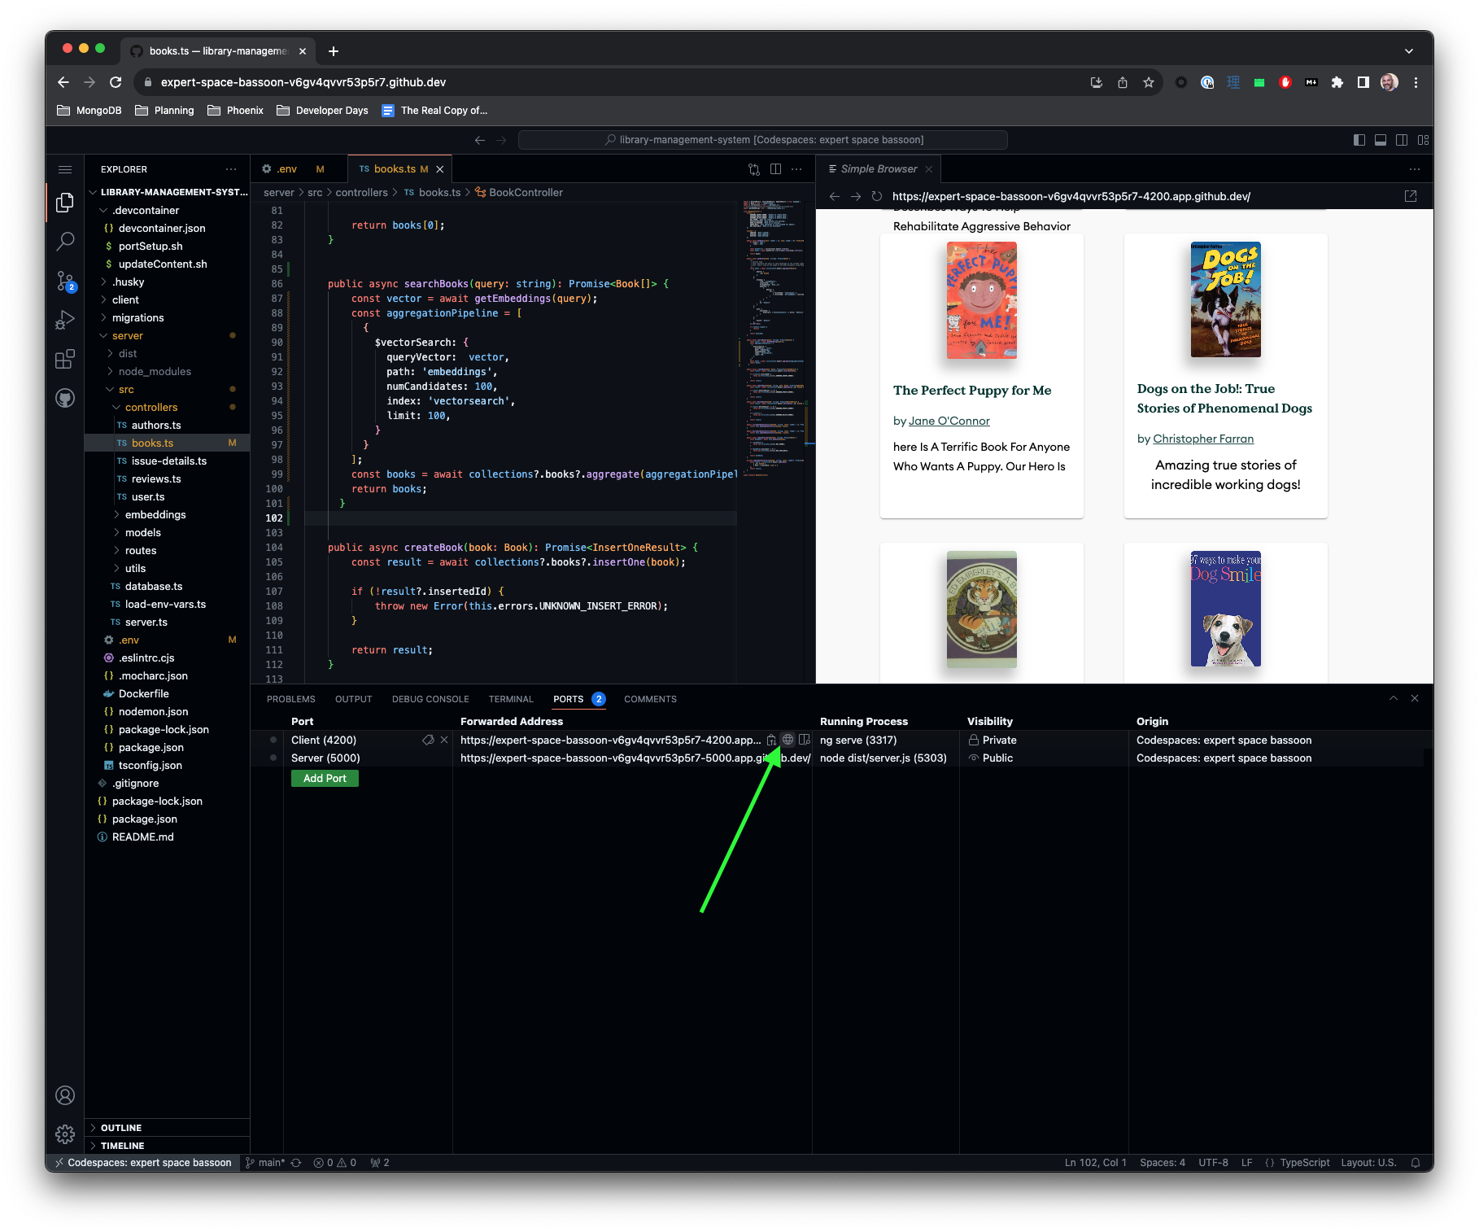

## Intro Lab: Codespaces not loading with pop-up blockers

Codespaces will have a problem if popup blocker is turned on and sometimes it keeps asking you for access which you have already given.

# 

## Intro Lab: not waiting for the library's app to build

Building the server + client takes some time. They'll see a notification at the bottom when everything is loaded OK. Then they should refresh the Simple browser tab.

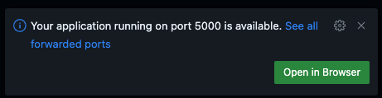

## Intro Lab: books are not loading

Troubleshooting:

* Check if the attendee has entered their connection string in .env. There should be an error in the terminal if they haven’t.
* Check the terminal for errors. Restart the process if needed by typing rs and hitting Enter.
* Navigate to the ‘Ports’ tab in the bottom sidebar and make sure the server port visibility is set to ‘Public’. Otherwise, the client app won’t be able to send requests to it.
* Go to Atlas and make sure they’ve actually imported data in the database cluster (some folks skip this step and jump straight to the application setup). If they haven’t, show them how to do it from [mdb.link/import-library-data](http://mdb.link/import-library-data). You might have to go through the security quickstart.